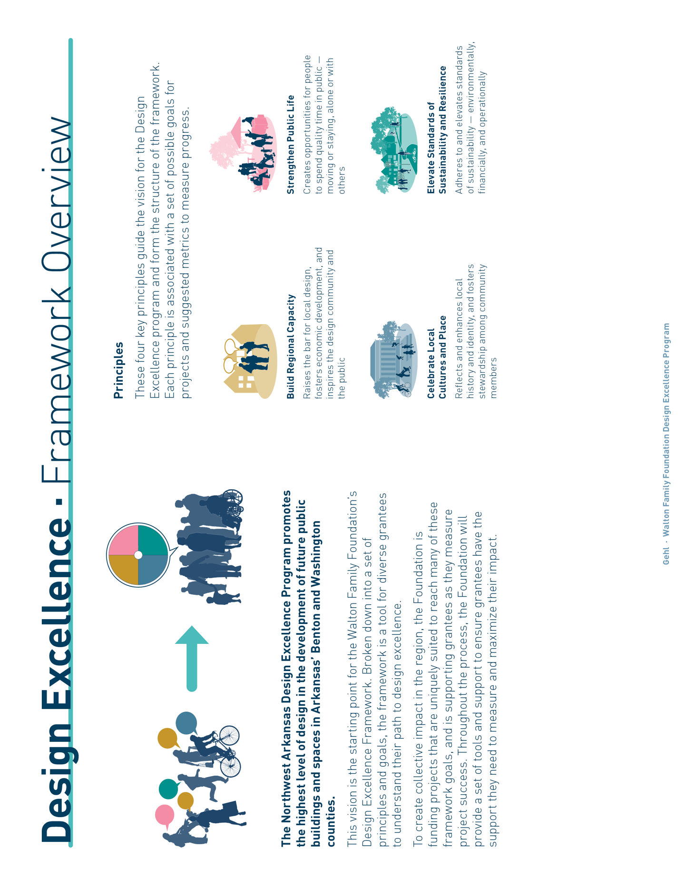
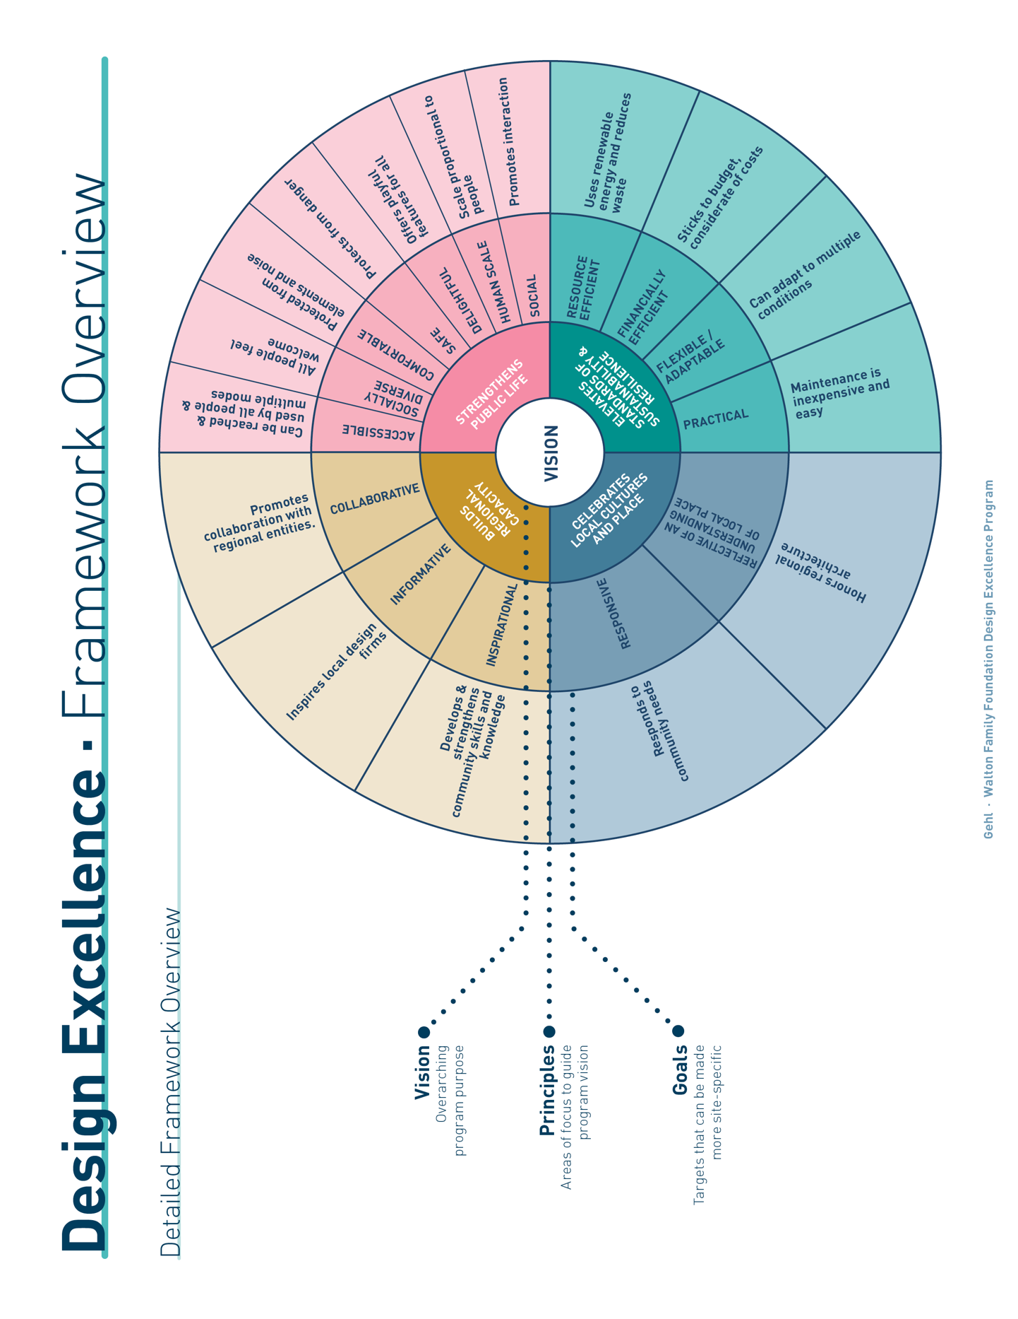
Project Goals Framework
Articulating Project Goals, Metrics, & Measurement Methods

You are applying for funding from the Walton Family Foundation to shape design excellence in Northwest Arkansas. Each project that the Foundation funds is unique, but we still want to know how yours relates to the Framework that guides the overall program.

In the worksheet on the following pages, provide a preliminary set of goals, metrics, and methods for your project. These aren’t final, and there will be plenty of opportunities to refine them if you are admitted to the Design Excellence program.

Required in Application Stage

What goals will you set?

Choose the Design Excellence goals that are most important to your project and explain how your project might fulfill each. (Note: While your project should address each Design Excellence principle, it doesn’t need to meet all goals of the framework. Select or add the goals that are priorities for your project.)

Optional in Application Stage

What metrics will you use to know you’re making progress toward your goals?

Aligned to each of your goals, metrics are the specific features or conditions that help you know you’re making progress. Sample metrics are provided in the worksheet. (Note: See Metrics Guide for more background on potential metrics.)

What measurement methods will you use to observe and collect data on your metrics?

There are four broad categories of measurement, as outlined below. (Note: See Methods Guide for more background on potential methods.)

- Gauge Perception: Understanding how people feel about a site or project. Methods include: Surveys; Focus Groups; Interviews; Community Engagement; Social Media Analysis
- Observe Activity: Documenting how people are using or moving through a site or project. Methods include: Moving Counts; Stationary Activity
- Map Conditions: Documenting the features and conditions of a space. Methods include: Place Inventory (e.g., spatial conditions like trees, seating); Connectivity Study (e.g., crosswalk timing for wait vs. walk vs. rush times, walking distance between key points)
- Collect Internal Data: Gathering financial, operational, or environmental data (e.g., budget reporting)

▼ D.E. Goal | ▼ How will your project fulfill this goal? (Required) | ▼ What metrics will you use to measure impact? (Optional) | ▼ What methods will you use to measure metrics? (Optional)
STRENGTHENS PUBLIC LIFE
ACCESSIBLE  Can be reached and used by all people and multiple modes |  | e.g., # of pedestrians moving through site | People Moving (mode)
SOCIALLY DIVERSE  All people feel welcome |  | e.g., # of senior citizens moving through site | People Moving (age and gender)
COMFORTABLE  Protected from elements and noise |  | e.g., # of shading trees per block | Place Inventory
SAFE  Protects from danger |  | e.g., User perception of safety | Intercept Survey
DELIGHTFUL  Offers playful features for all |  | e.g., # of people engaging in play per hour | People Staying
HUMAN SCALE  Scale proportional to people |  | e.g., # of ground-floor amenities | Place Inventory
SOCIAL  Promotes interaction |  | e.g., % of survey respondents who reported socializing with strangers or acquaintances | Intercept Survey
[ADDITIONAL GOALS OF YOUR CHOOSING]

ELEVATES STANDARDS OF SUSTAINABILITY AND RESILIENCE
RESOURCE EFFICIENT  Uses renewable energy and reduces waste |  | e.g., Annual energy use | Internal Reporting
FINANCIALLY EFFICIENT  Sticks to budget, considerate of costs |  | e.g., Budget performance | Budget Reporting
FLEXIBLE / ADAPTABLE  Can adapt to multiple conditions |  | e.g., # of adaptable elements on site (e.g., for programming or seasonal change) | Place Inventory
PRACTICAL  Maintenance is inexpensive, easy |  | e.g., # of staff hours required for maintenance per month | Internal Reporting
[ADDITIONAL GOALS OF YOUR CHOOSING]

CELEBRATES LOCAL CULTURES AND PLACE
REFLECTIVE OF AN UNDERSTANDING OF LOCAL PLACE  Honors regional architecture |  | e.g., Perceived incorporation of local culture among visitors to site | Intercept Survey
RESPONSIVE  Responds to community needs |  | e.g., # and diversity of stakeholders engaged | Community Engagement Reporting
[ADDITIONAL GOALS OF YOUR CHOOSING]

BUILDS REGIONAL CAPACITY
INSPIRATIONAL  Inspires local design firms |  | e.g., % of visitors to site who perceive it to be ‘world-class’ | Intercept Survey
INFORMATIVE  Develops and strengthens community skills and knowledge |  | e.g., # of regional design partners engaged throughout design process | Internal Reporting
COLLABORATIVE  Promotes collaboration with regional entities |  | e.g., # and type of local partnerships | Partnership Reporting
[ADDITIONAL GOALS OF YOUR CHOOSING]

OTHER PROJECT GOALS

